METHOD SPECFICATION
Faculty of Biosciences, NMBU

Method name: Urea
BIOVIT no.: msp 1012_feed and muscle

- Method of analysis / Principle / Main instrument

The method is intended for the determination of urea in feed and muscle.

The fish fed on diets that differed in levels of urea supplementation impact the incidence of salmon with ulcer, and subsequently its mortality that seems to relate to plasma osmolality. According to Rùrvik et al. (2000) the dietary urea supplementation may lead to reduced development of skin ulcers and will probably increase the proportion of market size salmon of superior quality.

Main instrument: RX Daytona + (Randox Laboratories Ltd, UK). 55 Diamond Road, Crumlin, County Antrim, BT29 4QY, United Kingdom. Kit: Urea (UR8334).

Urea concentration can be measured photometrically on a RX Daytona + spectrophotometer.
Reportable range: 0.50-62.0 mmol/L.
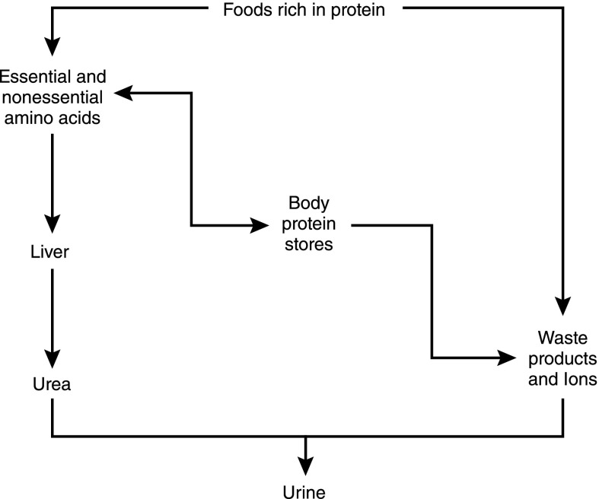

Overview of protein metabolism. Dietary protein intake can either be metabolized quickly to essential and nonessential amino acids or to metabolic waste products and ions. Essential and nonessential amino acids are interconvertible with body protein stores. Amino acids may also be metabolized through the liver to form urea, which is then excreted in the urine. Body protein stores can be converted back to essential and nonessential amino acids or may be metabolized, forming waste products and ions, which, as previously detailed, are excreted in the urine.

Source:
https://cjasn.asnjournals.org/content/10/8/1444

2. Reference and any modifications
In house method.

3.Requirements for the degree of grinding

Feed analysis, 1g ± 5 mg sample is required. Degree of grinding 0.5mm.
Fish muscle analysis, 15-20 g homogenized sample is required.
A control sample containing 5.1-6.2 % urea (RSD % 4,8), should be run with each batch.

Lab freezer storage is ideal for feed samples. If muscle sample/samples require longer (more than two days) of storage, it is typically advisable to opt for freezer storage at -18°C.

4. Contact person:

Lab leader: Hanne Kolsrud Hustoft
Responsible for analysis: Milena Bjelanovic

5. Additional literature
https://journals.physiology.org/doi/full/10.1152/advan.00027.2002

https://acutecaretesting.org/en/articles/urea-and-the-clinical-value-of-measuring-
blood-urea-concentration

https://www.researchgate.net/publication/230107985_Urea_in_feeds_for_sea_water_farmed_Atlantic_salmon_Effect_on_growth_carcass_quality_and_outbreaks_of_winter_ulcer

