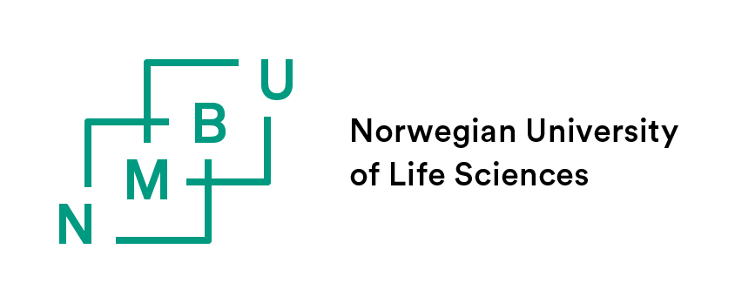
Proposal for the composition of the supervisory team

To be completed by the PhD candidate employed in a 1017 or 1378 position at the Faculty of Veterinary Medicine.

The form with its attachments is to be sent by e-mail to the PhD advisors: phd.radgiver.vet@nmbu.no, for further processing and approval. Please make sure that the proposed main supervisor receives a copy.

PhD candidate:
Department: | Choose an element
Employed in the periode:

Section 7 in the PhD regulations and supplementary rules at VET
The supervisory team consists of a main supervisor and normally 1-2 co-supervisors. All supervisors must hold a doctoral degree, or hold an assessed associate professorial or professorial competence, within a relevant academic field and be working actively as researchers. The main supervisor must be an employee of NMBU and have previous experience or training in serving as supervisor for PhD candidates. Read more on our website: https://www.nmbu.no/en/studies/study-options/phd/veterinary-sciences/implementation/supervising

THE FOLLOWING SUPERVISORS ARE SUGGESTED:
Main Supervisor:
Title and academic degree:
Position at NMBU:
Employed in a permanent position: | ☐ Yes ☐ No
Previous experience or training as supervisor: | ☐ Yes ☐ No
Reasoning:
Co-supervisor:
Title and academic degree:
Place of work:
Address:
Phone number:
E-mail:
Gender: | ☐ Female ☐ Male
Reasoning:
Co-supervisor^{i}:
Title and academic degree:
Place of work:
Address:
Phone number:
E-mail:
Gender: | ☐ Female ☐ Male
Reasoning:

Attachments:
☐ CV for external supervisors (not employed by NMBU)

Persons listed above have stated they are willing to act as PhD supervisors of the PhD candidate:
Yes ☐ No ☐

Date and signature: | Insert date here
PhD candidate: | Sending the proposal to the faculty by e-mail replaces the handwritten signature.
Main supervisor:
Head of Department:

Personal information (address, place of work, phone number, e-mail and gender) is only required for co-supervisors not employed by NMBU.

