 | Recognition as an Excellent Teaching Practitioner at NMBU Guide for applicants and the assessment committee
 | Prepared by: POA  Approved by: Rector  Date of approval: 25 February 2020 | Doc. ref.:  Replaces: | p360: 17/03917  NEW

Recognition as an Excellent Teaching Practitioner at NMBU – Guide for applicants and the assessment committee

This information is intended to serve as a guide to the assessment of applicants seeking recognition as an Excellent Teaching Practitioner at NMBU in 2020.

This document is based on an item submitted to the University Board concerning the introduction of an Excellent Teaching Practitioner (ETP) system at the Norwegian University of Life Sciences (NMBU). The University Board approved NMBU’s Excellent Teacher Practitioner system on 31 October 2019, as described in An explanation of the Excellent Teaching Practitioner system.

Eligible applicants include professors, associate professors, assistant professors, dosent professors, senior lecturers and clinical veterinarians, in permanent employment and with a teaching career of at least five years.

An application template and a template for the teaching portfolio have been developed for applicants.

A report template has been developed which may be used by the assessment committees.

For detailed information please refer to the relevant documents, available at https://www.nmbu.no/ansatt/laringssenteret/kurs-og-kompetanse/merittering

1 Requirements and criteria for assessment of teaching competence
Recognition as an Excellent Teaching Practitioner (Merittert underviser), is awarded to those who over time and systematically have developed their teaching competence to a level which is significantly higher than the expected basic competence. Assessment is made on the basis of the practitioner’s application and carried out by appointed assessment /steering committees.

The following criteria have been established for assessment of teaching competence:

1. Teaching in line with NMBU’s learning philosophy
• The applicant has a focus on student learning.
• The applicant facilitates, guides and supports the learning process.
• The applicant’s approach is based on student-active learning methods that promote reflection and independent work.
• The applicant has an awareness of the connection between teaching methods, learning outcomes, forms of assessment and types of learning.
• The applicant contributes to ensuring that the students are active participants in the academic/research environment, internally and/or externally

2. A clear development over time
• The applicant has deliberately and systemically strived to develop his/her teaching, both in form and content, in order to support student learning.
• The applicant has ideas and plans for his/her continued development work and the further development of his/her own teaching competence and practice in future.
• The applicant can refer to good teaching results.

3. A scholarly approach
• The applicant plans, maps, assesses and modifies his/her teaching practice to support student learning in the best possible manner.
• The applicant reflects on his/her own teaching activity in light of university pedagogical theory and subject didactic knowledge

4. A collegial attitude and practice
• The applicant shares his/her teaching experience and results with students and colleagues at NMBU.
• The applicant communicates and shares his/her teaching experience and results through e.g. seminars, conferences, reports or articles/publications.
• The applicant actively contributes to the development of the study programme(s) and/or the development of teaching and quality of teaching.

A qualitative assessment is made pursuant to the criteria, with two key perspectives: the holistic approach of the applicant and the integration of knowledge and teaching practice.

2. Application and teaching portfolio – Excellent Teaching Practitioner
Applicants shall prepare a teaching portfolio to provide a picture of how they over time, systematically, deliberately and based on knowledge of learning, have developed their teaching practice to help promote student learning, thereby documenting that they meet all four criteria.

Templates have been prepared for the ETP application and ETP teaching portfolio, see Appendix 1.

3. Assessment of applications for recognition of ETP status

The ETP award system of NMBU uses the Scholarship of Teaching and Learning (SoTL) as its theoretical foundation. SoTL emphasises the equal status of research/artistic work and education. The objective is that educators, based on the existing theory and knowledge, keep student learning in focus. Reflection on own practice and documentation of experience and sharing of knowledge in teaching environments are important elements.
The ETP system at NMBU is based on NMBU’s learning philosophy and shall serve to support this philosophy. The learning philosophy represents a view on learning whereby learning is created through the interaction between the teacher and the student and between students, and where student learning is kept in focus. See also section 1 Requirements and criteria for assessment of teaching competence.

An assessment is made on the basis of the practitioner’s application and is carried out by appointed assessment/steering committees.

An important objective of this system is to support the practitioner’s development as a teacher. Therefore, the committee’s report, whether it recommends awarding the ETP status or not, shall provide good feedback to the applicant with a view to further development.

In order to qualify as an ETP, the applicant must to some extent meet all the criteria and document the extent and nature of this compliance through the application and teaching portfolio with supporting documents. Recognition of ETP status requires that there can be no doubt that the criteria are met.

The applicant shall be assessed against all points in the criteria, and the report should describe and assess the applicant’s qualifications against each criterion. A qualitative assessment is made pursuant to the criteria, with two key perspectives: The applicant's holistic approach and integration of knowledge and teaching practice. The assessment of the application shall conclude with a recommendation in relation to whether the applicant should be called in for an interview. All candidates whose applications have been assessed as strong enough to indicate that the candidate can or should be awarded ETP status shall be interviewed.

The applicant’s interview shall complement the application and teaching portfolio, especially in relation to pedagogical views and teaching practice, and how these constitute an integrated whole. The interview shall largely be based on the submitted application so that the practitioner has an opportunity to elaborate on topics and give further examples.

The report shall conclude with a holistic assessment of the application and, if relevant, the interview, as well as a recommendation as to whether the applicant should be awarded the Excellent Teaching Practitioner status.

A report template has been prepared which may be used by the expert committees. See attachment 2.

Attachment 1: Templates for application and teaching portfolio – Excellent Teaching Practitioner
Applicants shall prepare a teaching portfolio to provide a picture of how they over time, systematically, deliberately and based on knowledge of learning, have developed their teaching practice to help promote student learning, thereby documenting that they meet all four criteria.

1 Introduction of the application
The introduction shall contain a brief summary of the applicant’s competence and profile. Furthermore, the applicant shall briefly explain how he/she believes to have met the criteria that have been established for recognition as an excellent teaching practitioner.
Extent: approximately 1-2 pages

2 Teaching CV
Here is an example of how a teaching CV may be structured. The CV should focus on your teaching practice and competence as a teaching practitioner and it should be structured to support your application for recognition as an Excellent Teaching Practitioner. However, other ways of presenting a teaching CV may be more suitable for you. Use the template as a guide and adapt it to adequately highlight your specific qualifications and experience. Applicants who have been practising for a long time do not need to include all details of their teaching and supervision experience throughout their career. Activities from more than 10 years ago do not need to be included unless these have been important in the development of your competence.

2.1 Personal details
Name
Address
Age
Phone
Mobile
Email
Website (if applicable)
Level of qualification (current position)
Field or profession
Current teaching and supervision responsibility

2.2 Teaching qualifications
Type of education/course | Time period | Institution
Formal education via a course in university pedagogy or equivalent

Course in supervision

Other types of course or formal qualifications in different areas of teaching and supervision

2.3 Teaching experience, particularly highlighting choice of objectives, methods and assessment
Level | Level, course, programme | Scope | Objectives, methods, assessment
Teaching experience: xxx

Teaching experience: xxx

Teaching experience: xxx

Teaching experience: xxx

Teaching experience: xxx

Teaching experience: xxx

2.4 Supervision experience

Supervision of PhD students
Name of PhD student and thesis area | University | Date of defence/date of completion | Principal supervisor  (cross off) | Co-supervisor  (cross off)

Supervision of master’s degree students
Year | Number of master’s degree students | University

Supervision of bachelor's degree students
Year | Number of bachelor’s degree students | University

2.5 Experience of assessment/evaluation of teaching and education
Experience of assessment/evaluation of teaching and education * | Level, course, programme | Scope | When | Role | At which institution
*E.g. the number of external examiner assignments per year, mutual peer guidance, participation in PhD committees, participation in evaluation at faculty or university level in national or international contexts

2.6 Educational development work
Development experience* | Level, course, programme | Scope | When | Role | Institution
*Examples: work on courses and study programmes, quality of education etc.

2.7 Experience sharing on teaching and supervision in the field
Type* | Scope | When | Role | Where
* Examples: Presentations, conferences, study trips of relevance to teaching

2.8 Administration and management of education
Administration and management of education* | Scope | When | Role | Where
*E.g. experience as an education manager, participation on programme councils, other committees relating to education, course coordination etc.)

2.9 Reference list of teaching-related publications
Publication | Publication channel | When | Number of pages | Language

3 Pedagogical reflection note
The pedagogical reflection note is a personal document intended to document the applicant’s qualifications in relation to the four criteria areas. It must set out the practitioner’s reflections on learning and teaching, based on his/her experience and knowledge, and supported by theories and research on learning.

Scope: The total scope of the note should not exceed 10 pages.
Language: The reflection part may be written in English or Norwegian.
Concrete examples: The reflection note must be based on concrete and relevant examples from the applicant’s teaching practice. Reasons must be provided for the choice of examples. Examples are a key element of the reflection note since examples themselves can shed light on the extent to which several of the criteria have been met.

The note should provide insight into:
- Reflection on the pedagogical and didactical views that serve as the foundation for teaching and supervision work.
- An explanation of how the applicant understands the relationship between learning and teaching in his/her teaching practice.
- An explanation of how the applicant has evaluated his/her own teaching and supervision practice and what bearing this evaluation has had on his/her teaching and supervision and the development of his/her teaching and supervision.
- Reflection on how the applicant has developed his/her view on learning and teaching practice over time, and how he/she plans to develop his/her teaching in future (plan for the further development of his/her teaching activities and qualifications, in addition to which areas for development he/she has identified)

4 Documentation that supports the reflection note and CV
- Diplomas, course certificates, sources that document and support sections 2.2-2.9 in the CV.
- Sources that support the content of the reflection note and examples from own teaching.
- Feedback from others on planning, implementation and evaluation of teaching and supervision (peer guidance, student evaluations in the past three years/other evaluations etc.)

Number of enclosures: maximum 15

Report template for the assessment committee: Assessment of application for recognition as an Excellent Teaching Practitioner

Aid for the assessment committee. The committee may choose to use this template or develop its own format.

Contents:
- Personal details
- Formal requirements for applicants
- Formal requirements for the application
- Assessment against the criteria

Assessment of holistic approach and integration of knowledge and teaching practice.

1 Personal details
Name of applicant
The applicant’s competence level
The applicant’s field/profession

2 Formal requirements for applicants
The applicant has been employed by NMBU for five years
The applicant is a permanent employee
The applicant belongs to one of the following job categories: professor, associate professor, assistant professor, dosent professor, senior lecturer and clinical veterinarian

3 Formal requirements for the application
The application was submitted by the deadline.
The application includes a cover letter providing a brief summary of the applicant’s competence and profile. Furthermore, the applicant must briefly describe why he/she believes to have met the criteria that have been established for an Excellent Teaching Practitioner.
The application includes a reflection note of maximum 10 pages, the content of which meets the documentation requirements described in the call for applications.
A CV and documentation have been enclosed to support the letter and the note, the content of which meets the documentation requirements described in the call for applications.

4 Assessment against the criteria

Assessment of the criteria takes place on the basis of the reflection note and the information provided in the CV and pertaining documentation.

Main criteria and sub-points | The committee has assessed whether the application provides concrete and satisfactory answers to the following questions
1. Teaching in line with NMBU’s learning philosophy  • The applicant has a focus on student learning  • The applicant facilitates, guides and supports the learning process.  • The applicant’s approach is based on student-active learning methods that promote reflection and independent work.  • The applicant has an awareness of the connection between teaching methods, learning outcomes, forms of assessment and types of learning  • The applicant contributes to ensuring that the students are active participants in the academic/research environment, internally and/or externally | To what extent are the teaching initiatives described by the applicant based on consideration for student learning?  How does the applicant deal with the connections between forms of teaching, forms of assessment and learning outcomes in the teaching initiatives he/she has presented in the application?  How has the applicant contributed to ensuring that the students are active participants in the academic/research environment?
2. A clear development over time  • The applicant has deliberately and systemically strived to develop his/her teaching, both in form and content, in order to support student learning  • The applicant has ideas and plans for his/her continued development work and the further development of his/her own teaching competence and practice in future.  • The applicant can refer to good teaching results. | What role has consideration for student learning played in the applicant’s development of his/her teaching over time?  To what extent does the applicant demonstrate an understanding of the complexity of student learning? And to what extent does the applicant demonstrate an ability to reflect on and draw conclusions from student learning?  What concrete plans does the applicant have for the further development of teaching that promotes learning?
3. A scholarly approach  • The applicant plans, maps, assesses and modifies his/her teaching practice to support student learning in the best possible manner.  • The applicant reflects on his/her own teaching activity in light of university pedagogical theory and subject didactic knowledge | To what extent does the applicant model his/her teaching on the research process: with collection of data on how well the teaching promotes student learning, analysis of the data and changing the teaching on the basis of the results?  To what extent does the applicant refer to research on learning and teaching that is relevant to the challenges the applicant is interested in?
4. A collegial attitude and practice  • The applicant shares his/her teaching experiences and results with students and colleagues at NMBU.  • The applicant communicates and shares his/her teaching experience and results through e.g. seminars, conferences, reports or articles/publications.  • The applicant actively contributes to the development of the study programme(s) and/or the development of teaching and quality of teaching. | Does the applicant actively contribute to a collegial community in connection with the development of teaching?  Does the applicant participate in academic discussion of teaching and learning in higher education, beyond his/her own environment?  Does the applicant actively contribute to the development of study programme(s) and/or the development of teaching and quality of teaching at NMBU?

The committee assesses the degree to which the application meets each individual criterion, on the following scale:

- Does not meet the criterion
- Does not meet the criterion to a sufficient extent
- Meets the criterion to a sufficient extent
- Meets the criterion to a great extent

The application must meet all four criteria to a sufficient extent or to a great degree in order to qualify for recognition as ETP.

5 Assessment of holistic thinking and integration of knowledge and teaching practice
The assessment of holistic thinking and integration of knowledge and teaching practice must be made on the basis of the documentation as a whole, where the applicant describes, reflects on and motivates his/her teaching activity in relation to student learning. Examples from his/her teaching are a key element of the application since examples themselves can shed light on the extent to which the criteria have been met. In addition, the teaching must be seen in a framework of pedagogical knowledge, see the main criteria above.

SoTL emphasises the equal status of research and education. The objective is that educators, based on existing knowledge, place student learning in focus. Reflection on own practice and documentation of experience and sharing of knowledge in teaching environments are important elements.

Once the SoTL perspective on education becomes more widespread, there will be more research on education and student learning and more arenas for sharing knowledge. SoTL connects the research to the academic environment – it is there the development of knowledge and terminology will take place, as well as, to a lesser extent, in traditional teaching environments.
This means that SoTL emphasises a research-based teaching practice. This is also a key element in NMPU’s ETP system and permeates all four criteria areas.

The model below has been developed through a research project which studied the first three rounds of the Pedagogical Academy at Lund University (Antman & Olsson, 2007).

The criteria are essential for the qualitative assessment of teaching competence. An overall assessment may also be made within these criteria, on the basis of theory and pedagogical practice, and how well these perspectives are integrated with each other.

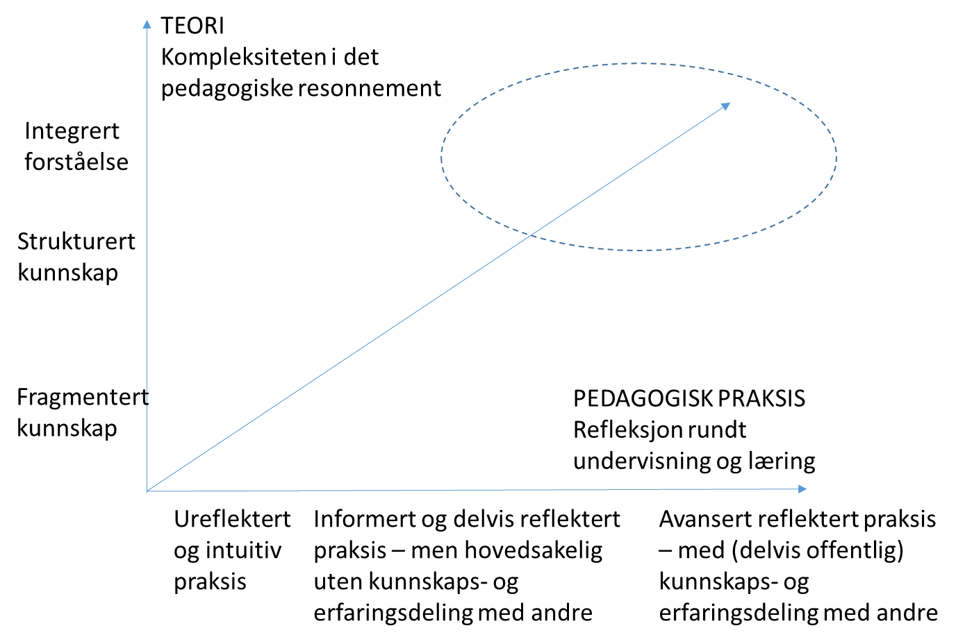

TEORI | THEORY
Kompleksiteten i det pedagogiske resonnement | The complexity of the pedagogical reasoning
PEDAGOGISK PRAKSIS  Refleksjon rundt undervisning og læring | TEACHING PRACTICE  Reflection on teaching and learning
Integrert forståelse | Integrated understanding
Strukturert kunnskap | Structured knowledge
Fragmentert kunnskap | Fragmented knowledge
Ureflektert og intituitiv praksis | Unreflective and intuitive practice
Informert og delvis reflektert praksis – men hovedsakelig uten kunnskaps- og erfaringsdeling med andre | Informed and partly reflective practice – however, mainly without sharing knowledge and experience with others
Avansert reflektert praksis – med (delvis offentlig) kunnskaps- og erfaringsdeling med andre | Advanced reflective practice – with (partly public) sharing of knowledge and experience with others

This model includes two dimensions which at an overlying level show the possible progression of the pedagogical development. The theoretical knowledge is developed from fragmented knowledge, turning into more structured knowledge, and then becoming an integrated holistic understanding. The pedagogical practice is developed from an intuitive or unreflective practice, moving on to a more reflective practice, with an increasing exchange of knowledge and experience with others.

There is no simple correlation between teaching proficiency and student learning outcome. A pedagogically proficient teacher, however, must be able to understand the complexity of student learning and be able to demonstrate an ability to reflect on his/her teaching, student learning and theories on teaching and learning This ability varies from unreflective observations (or lack of observations) of student learning to increasing reflection, systematic examinations and reflective analyses of student learning.

The pedagogical reflection note, complemented with other documentation, shall provide an image of where the applicant stands between the two axes in the model.

Can the applicant, through his/her application, substantiate that he/she has come a long way on both axes, and as such, has developed a research-based teaching practice?

- Does not meet the criterion
- Does not meet the criterion to a sufficient extent
- Meets the criterion to a sufficient extent
- Meets the criterion to a great extent

The application must meet this criterion to a sufficient or great extent in order to qualify for recognition as ETP.

