1. Go to https://nmbuwritingcentre.setmore.com/class, click the icon to choose the Webinar | 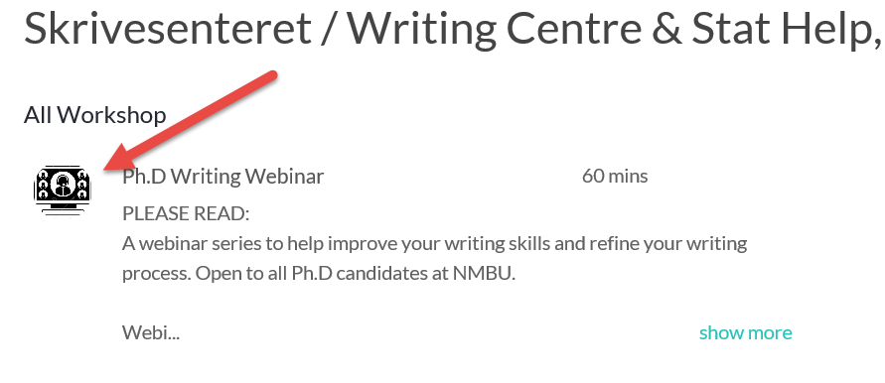
2. Click Okay to accept the booking policy | 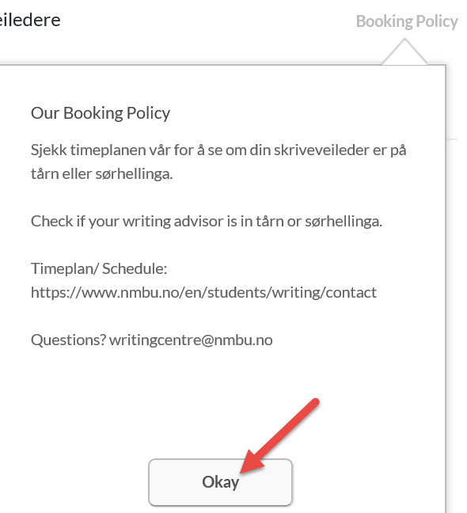
3. Choose Niklas to go to next step | 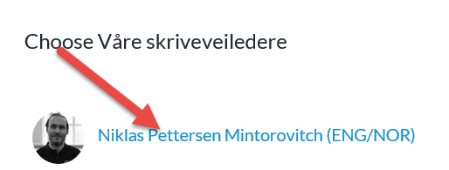
4. Click 12:00 to go to next step | 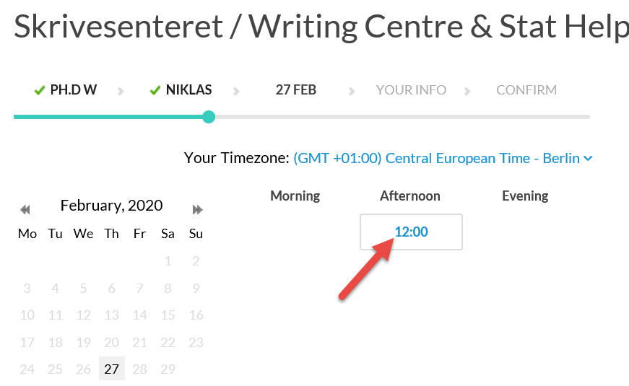
5. Sign In (to the booking system) with existing profile or create a new profile | 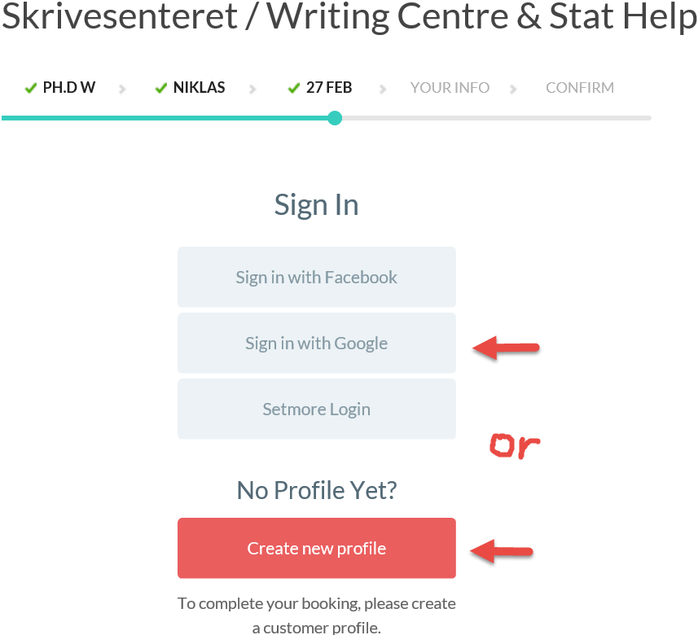
6. Check/register and confirm your information  7. Book the workshop! You may choose to receive reminder e-mail or sms.  8. When finished, your registration confirmation looks like this: | 