10th International Conference on Monitoring and Management of Visitors in Recreational and Protected Areas (MMV10), Lillehammer, Norway, August 24-27, 2020

Authors’ instructions for extended abstracts

An extended abstract of maximum 1000 words + one figure or table should be submitted to the conference organizer by March 31st, 2020, and upon submission please adhere to the below guidelines. Abstracts will thereafter be reviewed by the steering committee and feedback will be given to authors by May 15th. Revised abstracts based on this review must thereafter be submitted to the conference organizer no later than May 31st, 2020.

It is important that your text uses clear and correct English language. We reserve the right to make grammatical and linguistic changes. The extended abstract will be published in the conference proceedings (electronic format) and be available to the participants upon arrival at the conference.

If one believes it to be relevant, a thematic session to be referred to can be selected from the list that is indicated in the conference website.

Save the document in MS Word format using the First and Family name of the presenter, for example john.smith.doc. E-mail the document (and your figure/table) no later than March 31st, 2020 to: mmv10@nmbu.no
By submitting your abstract, you accept that the text will be available on the MMV website, and that it will be archived.
___________________________________________________________________________________________

Title (Arial 16 pt, bold)

Name, affiliation, nationality and e-mail of first author (Times New Roman, italics, 11 pt)
Name, affiliation and nationality of co-author(s) if applicable (Times New Roman, italic, 11 pt)

Chosen parallel sessions (if any):

Type of presentation (paper or poster):

Main text (Times New Roman, 12 pt, single spaced, maximum 1000 words) Main text (Times New Roman, 12 pt, single spaced, maximum 1000 words) Main text (Times New Roman, 12 pt, single spaced, maximum 1000 words) Main text (Times New Roman, 12 pt, single spaced, maximum 1000 words) Main text (Times New Roman, 12 pt, single spaced, maximum 1000 words) …

Main headline (Arial 14 pt, bold)

Second headline (Arial 12 pt, italic)

Main text (Times New Roman, 12 pt, single spaced, maximum 1000 words) Main text (Times New Roman, 12 pt, single spaced, maximum 1000 words) Main text (Times New Roman, 12 pt, single spaced, maximum 1000 words) Main text (Times New Roman, 12 pt, single spaced, maximum 1000 words) Main text (Times New Roman, 12 pt, single spaced, maximum 1000 words) …

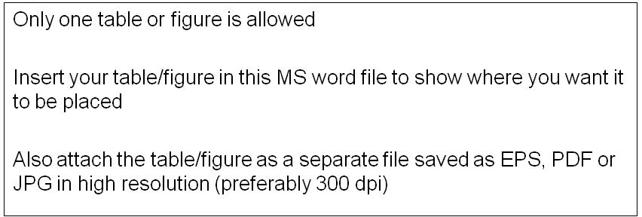

Figure/table captions (Arial 10)

Main text (Times New Roman, 12 pt, single spaced, maximum 1000 words) Main text (Times New Roman, 12 pt, single spaced, maximum 1000 words) Main text (Times New Roman, 12 pt, single spaced, maximum 1000 words) Main text (Times New Roman, 12 pt, single spaced, maximum 1000 words) Main text (Times New Roman, 12 pt, single spaced, maximum 1000 words) …

References (Times New Roman, 10 pt, maximum six references, Harvard system)
References (Times New Roman, 10 pt, maximum six references, Harvard system)
References (Times New Roman, 10 pt, maximum six references, Harvard system)
…

_________________________________________________________________________________

Please do not use end- or footnotes!

