Course Evaluation of a NOVA PhD Course "Phenotyping Technologies in Plant-environment Interactions - Integrated Analysis of Omics Data"
Course year: 2018

Number of respondents: 21

A. How did the teaching methods applied in this course contribute to achievement of the learning outcomes?

(1 = very little, 6 = very much)

B. How would you describe the academic level, the progression and the workload of the course?

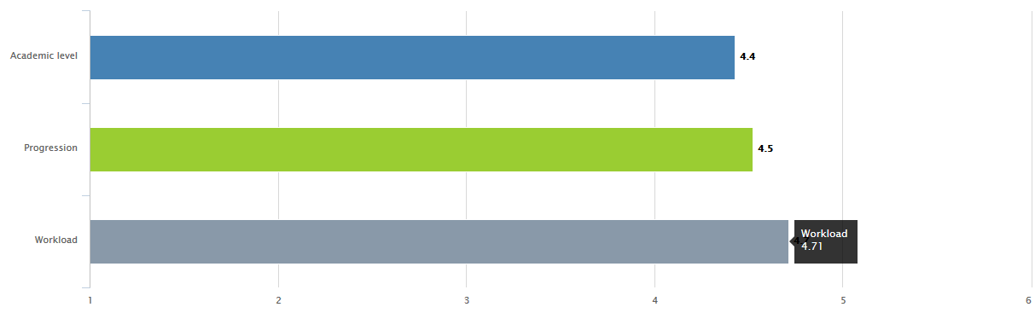

(1 = too low/slow/little, 6 = too high/fast/much)

C. To what extent do you agree or disagree with the following statements?

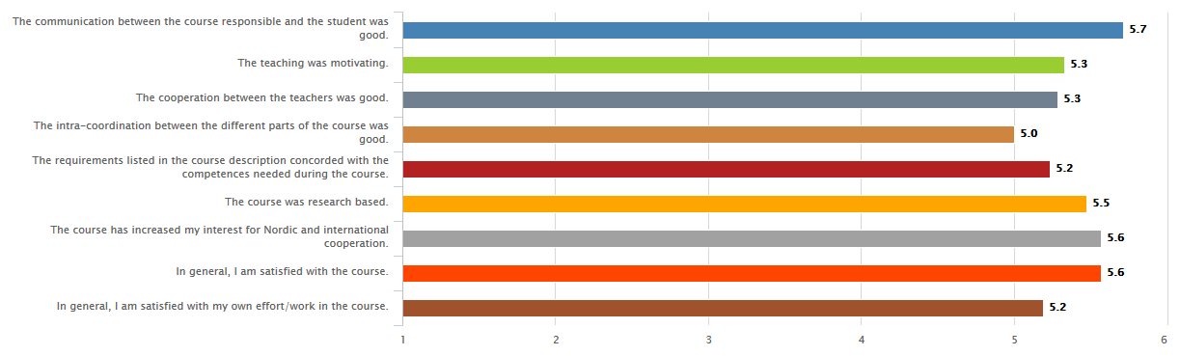
(1 = totally disagree, 6 = totally agree)

