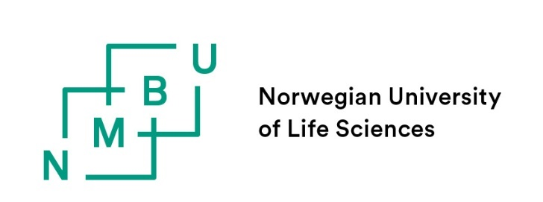

FORM 4.7 Errata

Application for permission to correct formal errors in the thesis

Errata is a list of corrections made in a thesis after it has been approved, but before it is printed.

The PhD candidate may apply for permission to correct formal errors in the thesis (cf. the PhD regulations, section15.3-2). The application must include a complete list of the errors that the PhD candidate wishes to correct. The application must be e-mailed to the faculty PhD contact person at the latest 4 weeks before the planned disputation date.
An errata application can be made only once. The errata list must be inserted as the last page of the printed version of the thesis.
It is allowed to correct the following formal errors:
- spelling and language mistakes that make the text linguistically incorrect
- punctuation and reference errors
- page layout, text format etc.
It is not allowed to:
- specify or change the meaning of the text
- make changes in tables
- change version or change status in manuscripts/ articles in your PhD thesis. For example, an article with the status "in press" cannot be exchanged with a journal's printed version, and change status to "published" prior to printing.
Corrections to the cover, in preface and acknowledgements, can be made without applying for permission.

Name of PhD candidate:
Thesis title:

The application is to be signed by the PhD candidate and the main supervisor and sent to the faculty for approval.
Signatures and dates:
PhD candidate: |  | Date:

Main supervisor: |  | Date:

Errata approved by the faculty: Yes ☐ No ☐
For the faculty: |  | Date:
Errata list

PhD candidate:
Thesis:
Date:

Side | Line | Original text | Corrected text

