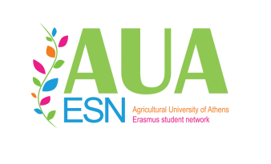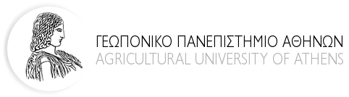
AGRICULTURAL UNIVERSITY OF ATHENS

2017/2018

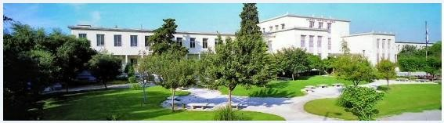

STUDENT GUIDE
For Erasmus Students

Contents

Welcome to the Agricultural University of Athens (A.U.A.) 3
A brief historical background of the A.U.A. 4
A.U.A. today 5
Map of A.U.A. 6
Arriving at the A.U.A 7
Courses, Examinations, Grading of Qualification 8
University Registration 9
A.U.A. Campus Info 10
Coordinators 13
Athens Student’s Guide 15
Entertainment and cultural life in Athens 21
Places to visit in Athens (http://www.culture.gr) 25
Useful Telephone Numbers 29
Useful Websites 30

Welcome to the Agricultural University of Athens (A.U.A.)

Agriculture and Culture, two senses very close and extremely important. Agriculture is related to the cultivation of the land and Culture to the cultivation of the mind. We begin from something settled, the land and the mind, which in collaboration with the human capital can produce seeds. Their quality depends on the rhythm of our work and our capacity to develop.

In this framework the contact with other cultures is very significant as we have the opportunity to broaden our mind. That is to say that the exchange of knowledge and experience in the framework of Erasmus+ Programme is going to help you to be in contact with different countries, people and mentalities.

The Agricultural University of Athens (A.U.A.) is the place that makes the difference and the new environment where you may pass a part of your study Programme combining the agricultural experience you already have with the new one. All the staff of the A.U.A. is willing to help you to integrate from the very beginning till the end of your stay. Moreover, we hope that the variety of Faculties
(Crop Science, Animal Science & Aquaculture, Biotechnology, Agricultural Economics & Rural Development, Food Science & Human Nutrition, Natural Resources Management & Agricultural Engineering) initiated by the A.U.A. is going to respond to your expectations and your specific interests.

Dear student,
The Agricultural University of Athens welcomes you and wishes you a successful Erasmus study period and an unforgettable stay in Athens. Looking forward to meeting you in Athens, we give you some practical information you may need before your arrival and during your stay in Greece.

A brief historical background of the Agricultural University of Athens

The Agricultural University of Athens is the third oldest University of Greece and the first devoted to agriculture. Its history goes back to 1920 and its impact on the development of Greek agriculture has been very significant.
Its historic location near Kerameikos and along Iera Odos, the oldest street of Europe, is inseparably linked to the ancient Greek traditions of agriculture. Iera Odos was the route along which the ritual procession to worship Demeter, the goddess of agriculture, passed to end in Elefsina, the town of Triptolemos, who spread agriculture throughout Europe.

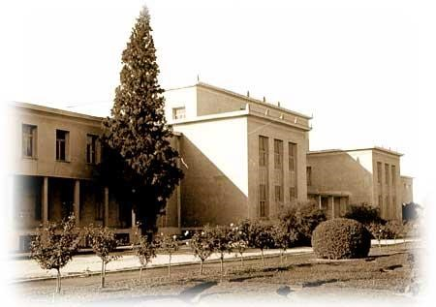

The Agricultural University of Athens today

Nowadays, the A.U.A. has more than 200 teaching and research staff, approximately 2.000 students plus associated administrative and technical personnel. The University is actively involved in the promotion of agricultural research and teaching in collaboration with other institutions. It comprises 6 Faculties and awards 6 undergraduate degrees in:

- Crop Science
- Animal Science and Aquaculture
- Biotechnology
- Agricultural Economics and Rural Development
- Food Science and Human Nutrition
- Natural Resources Management and Agricultural Engineering

All 6 faculties of A.U.A. have initiated postgraduate courses which lead to M.Sc. as well as Ph.D. degrees 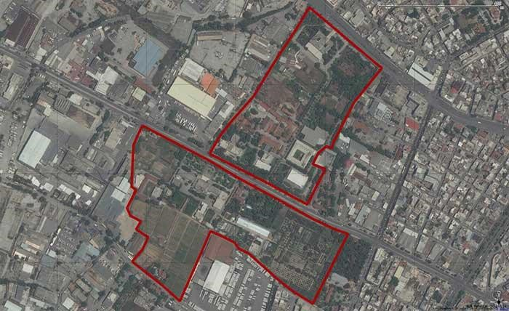

Map of Agricultural University of Athens
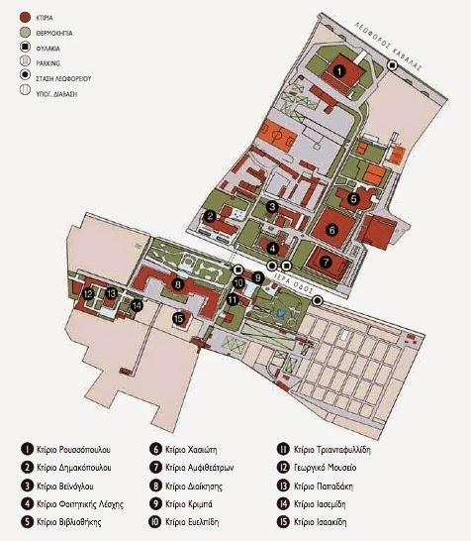
The University campus covers an area of 34 acres and is located on either sides of Iera Odos, near the ancient cemetery of Kerameikos in the district of Votanikos. The campus consists of 14 main buildings (offices, amphitheatres, laboratories, library, leisure centre and restaurant), associated installations (gardens, stables, plantations, greenhouses, vineyards, sports fields). Additionally, the A.U.A. owns facilities and experimental fields in Kopaida, Oropo, Spata and Messinia.

- Roussopoulou  - Dimakopoulou  - Veinoglou  - Students’ club (gum, restaurant, canteen)  - Library  - Hassioti  - Lectures’ Hall | - Central Administration Building  - Kriba  - Evelpidi  - Triantafyllidi  - Agriculture Museum  - Papadaki  - Iasemidi  - Isaakidi

Arriving at the A.U.A.
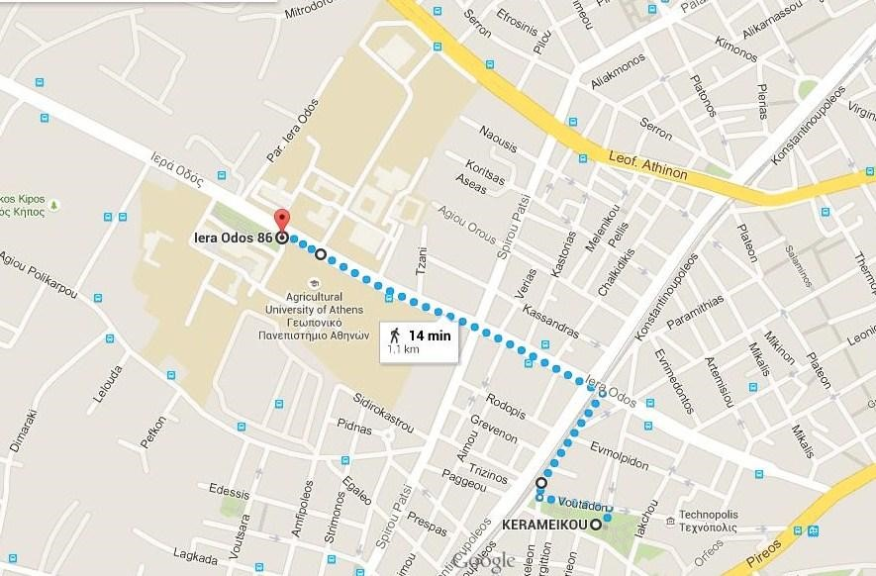
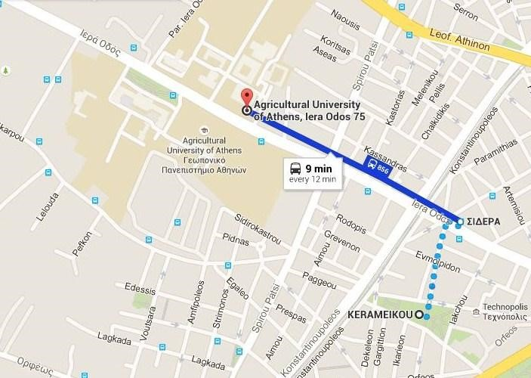
In order to arrive to the A.U.A. campus you can use a number of buses whose numbers are the followings: 813, 856, Α16, 026, 027. For more information on bus routes visit www.oasa.gr/. In addition you may use the metro (Line 3): stations “Kerameikos” and “Eleonas” (www.amel.gr).
Coming to AUA on foot from Kerameikos Metro Station Exit “Konstantinoupoleos”)
Coming to AUA by bus from “Kerameikos” Metro Station (Exit Technopolis/Gazi, take bus from “Sidera” bus station and go to “Geoponiki Scholi” bus station.

Courses, Examinations, Grading of Qualification
Studies at the A.U.A. last 5 years and its courses are divided in two annual semesters (autumn and spring). Lessons include lectures and laboratory work. Lectures normally take place in the morning (from 08:30 to 13:00) and laboratory work takes place during midday hours (from 14:30 to 17:00).

The grading scale used in the A.U.A. is the following:
- Type of scale 1-10
- Highest grade 10
- Lowest passing grade 5

EUROPEAN CREDIT TRANSFER SYSTEM

A: 9 – 10 EXCELLENT – outstanding performance with only minor errors

B: 8 VERYGOOD - above the average standard but with some errors

C: 7 GOOD - generally sound work with a number of no table errors

D: 6 SATISFACTORY - fair but with significant shortcomings

E: 5 SUFFICIENT - performance meets the minimum criteria

Fx: 3-4 FAIL - some more work required before the credit can be awarded

F: 1-2 FAIL – considerable further work is required

University Registration
Upon their arrival in Athens, Erasmus students should visit the European Programmes Office and register. The Office will provide them with the Student Identity Card, the Restaurant Card and the Library Borrowing Card, valid for the period of study at the A.U.A.

The European Programmes Office is located on the ground floor of the University’s Central Administration Building (corridor of Laboratory of Agronomy) and it is open on Monday, Wednesday and Thursday from 10:00 to 12:00 (address: Agricultural University of Athens, European Programmes Office, 75, Iera Odos str, 118 55 Athens,tel:+30210 5294819-823-927,e-mail:european_pr@aua.gr).
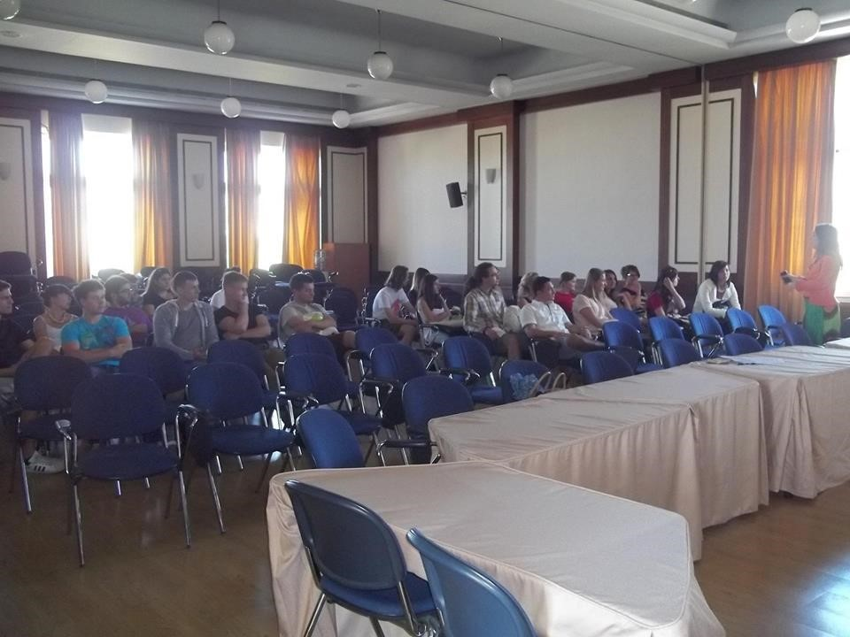

AUA Campus Info

Library
The central library of A.U.A. is situated in a separate building in the University campus (number 13 in the map of A.U.A.). All staff and students of the University community have the right to use the library facilities and may borrow material in accordance with the library rules.
The library offers a wide range of books and journals relating to the various activities and disciplines of the Faculties and Laboratories. Students must register to the library and use the library card every time they want to borrow books. Students have the right to borrow up to 5 books for a 10 days period, renewable subject to demand. Failure to return the loaned material by the agreed date, loss or damage of loaned material renders the borrower liable to a fine. The library does not loan journals, doctoral thesis or material of special or historic value.
Additionally, the Library offers computer facilities and Wireless Internet Connection.
For further information and opening hours please visit the library
site http://library.aua.gr/
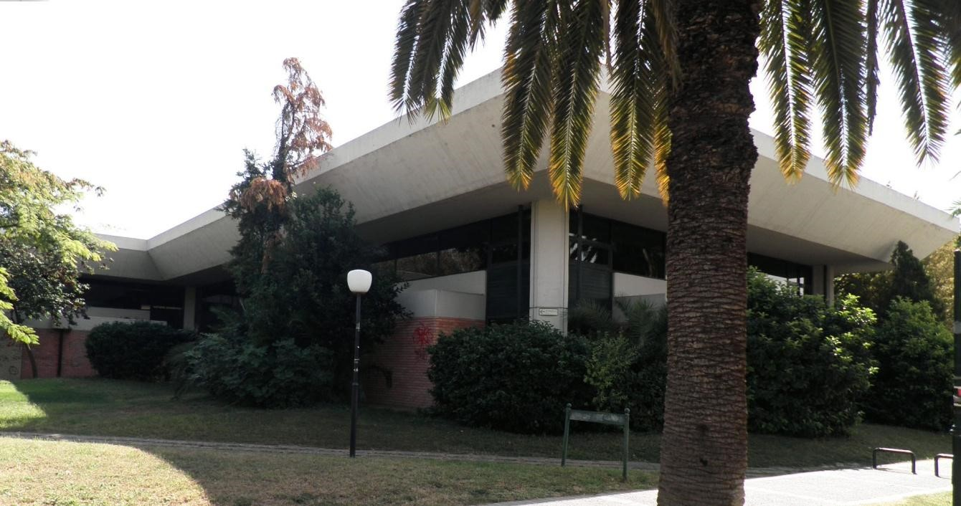

Accommodation
The A.U.A. does not have a student hall of residence. Exchange students can find flats in many internet platforms. They can also search in the list of flats we keep in the European Programmes’ Office, where previous Erasmus students have lived in.

Student Restaurant and Canteen
There is a student restaurant as well as a canteen for the purchase of snacks and soft drinks. The opening hours are as follows:
Restaurant: lunch from 12:00 to 15:00, dinner from 18:00 to 20:30.
Canteen: from 07:00 to 18:00 (excluding weekends)

Sports Facilities
Indoor Leisure Center: there is place for athletics and aerobic from 06:30 to 14:00 (Monday to Friday), information: +30 210 529 4954. Other sport facilities: Open air courts for tennis, volleyball, basketball.

Cultural Activities
Besides its role in education and research, the A.U.A. is also interested in promoting cultural activities. In this respect, the following groups have been established and are currently active: dance, theatre, music and a choir. Additional activities include the organization of sport events.

Health Care
To get healthcare through the public system in Greece and in all the countries of the European Union (EU), if you become ill or injured while on a temporary stay, European Union nationals may obtain in their home country Form E 111 (for emergency care) or Form E 128 (also for non-emergency care, valid for the length of the course). In place of the above mentioned E-forms, from 1 June 2004 has been introduced in some countries the European Health Insurance Card (EHIC). Through them and the EHIC you have access to the National Health System under the same conditions as nationals of the member state you are visiting.
Students coming from non-EU countries must make arrangements for health insurance before entering Greece. It is the responsibility of the Sending
University to provide insurance cover to students for the period of their stay at A.U.A.

University Medical Services
Next to the Greenhouse, University Campus
Mr. Baoussis Evangelos
Monday to Friday 09:00 to 12:00
Tel: +30 210 529 4898

Coordinators

Erasmus Institutional Coordinator
Professor Paplomatas Epaminondas, Vice Rector of Academic Affairs and
Personnel (Rectory, Central Building, 1stfloor)
Tel: +30 210 5294802, e-mail: vr2@aua.gr

Department of Crop Science
Departmental Coordinator: Professor Bebeli Penelope (Building No 3, 1st floor)
Tel: +30 210 529 4622, e-mail: bebeli@aua.gr
Deputy Departmental Coordinator: Professor Arapis Gerassimos (Building No 13, 2nd floor)
Tel: +30 210 529 4465, e-mail: mani@aua.gr

Department of Animal Science & Aquaculture
Departmental Coordinator: Assistant Professor Hager Ariadni (Building No 10, 2ndfloor)
Tel: +30 210 5294446, e-mail: a.hager@aua.gr
Deputy Departmental Coordinator: Assistant Professor Mountzouris
Konstantinos (Building No 10, 1stfloor)
Tel: +30 210 529 4422, e-mail: kmountzouris@aua.gr

Department of Natural Resources Management & AgriculturalEngineering
Departmental Coordinator: Professor Briassoulis Dimitrios (Building No 16, 1stfloor)
Tel: +30 210 529 4011, e-mail: briassou@aua.gr
Deputy Departmental Coordinator: Associate Professor Argyrokastritis Ioannis (Building No 16, 1st floor)
Tel: +30 210 529 4077, e-mail: jarg@aua.gr

Department of Food Science & Human Nutrition
Departmental Coordinator: Professor Drossinos Eleftherios (Building No 13, ground floor)
Tel: +30 210 529 4713, e-mail: ehd@aua.gr
Deputy Departmental Coordinator: Associate Professor Kapsokefalou Maria (Building No 13, ground floor)
Tel: +30 210 529 4708, e-mail: kapsok@aua.gr

Department of Biotechnology
Departmental Coordinator: Assistant Professor Rigas Stamatis (Building No 13, 2nd floor) Tel: +30 210 5294210, e-mail: srigas@aua.gr
Deputy Departmental Coordinator: Assistant Professor Eleni Douni (Building No 13, 2nd floor)
Tel: +30 210 4372, e-mail: douni@aua.gr

Department of Agricultural Economics & Rural Development
Departmental Coordinator: Asocciate Professor Koutsouris Alexandros (Building No 7, ground floor)
Tel: +30 210 529 4721, e-mail: koutsouris@aua.gr
Deputy Departmental Coordinator: Associate Professor Kostopoulou Konstantina (Building No 16, 1stFloor)
Tel: +30 210 5294721, e-mail: tina@aua.gr

CONTACT

Ms. Thania Anastopoulou, European Cooperation Coordinator
Tel. +30 210 529 4819, e-mail: european_pr@aua.gr
Ms. Vicky Griva
Tel. +30 210 529 4823
Mr. Zahos Athanasakis
Tel. +30 210 529 4927
Address:
Agricultural University of Athens
European Programmes’ Office
75, Iera Odos str.
118 55 Athens
GREECE
Find us at the ground floor of the Central Building (No 1, corridor of Laboratory of Agronomy)
OPENING HOURS: Monday, Wednesday and Thursday 10 am to 12 am
For more information about your Erasmus in AUA visit:
http://www.european.aua.gr/?page_id=757
and ESN AUA Athens website:
http://aua.esngreece.gr/

Athens Student’s Guide

ARRIVING AT THE ATHENS INTERNATIONAL AIRPORT “ELEFTHERIOS VENIZELOS”
The Athens International Airport is located 44 km north-eastern of Athens and can be rapidly accessed via a six-lane motorway ("Attiki Odos"), by express busses on a 24h basis (www.oasa.gr), by metro (www.amel.gr) and Suburban Railway (www.proastiakos.gr)- from Athens center and the port of Piraeus, ensuring this way efficient transport of air travelers and facilitating linkage to key tourist attractions.

TRANSPORTΑΤΙΟΝ IN ATHENS
The unified ticket is valid for all transportation in all means of Mass Transportation (metro, tram, buses, trolley-buses) for unlimited rides for 90 minutes from the time of its validation. The student ticket costs 0,60 € while the normal 1,40 €. You should validate your ticket upon boarding on the vehicle (bus, trolley-busses) or entering the station (metro, tram) or possess a valid transportation card (daily, weekly, monthly, yearly). You can buy tickets in all stations and in kiosks (periptera). More details about tickets/cards/prices/routes at http://www.stasy.gr/

Athens Metro (www.amel.gr).
The metro network system has 3 lines and 52 stations in total; line 1 (from Piraeus to Kifissia), line 2 (from Anthoupoli to Elliniko), line 3 (from Aghia Marina to Doukissis Plakentias to Airport). You can buy tickets and cards at the entrance of each station, where they are also validated before you enter the metro.

Public Urban Transportation (buses and trolley-buses) (www.oasa.gr). Tickets must be validated upon boarding in special validation machines within the vehicle (there is a penalty fine for not stamping your ticket).

Athens TRAM (www.tramsa.gr).
There are the 3 routes of the Tram:
- THUKIDIDIS 3: From SEF to ASKLIPIO VOULA
- ARISTOTELIS 4: From SYNTAGMA to SEF
- PLATONAS 5: From SYNTAGMA to ASKLIPIO VOULA
The tram operates daily from 05:00 am to 01:00 am while on Fridays and Saturdays it operates 24 hours

TAXIS
Taxis in Athens are yellow. They can be found at special stops or in motion. The flag – falling is 1,19 € and there is a minimum charge of 3,20 € regardless of the distance. Between 24:00 and 5:00 there is a double tariff. The amount payable is indicated on the taximeter of the car, except in cases where there is an extra charge (transport from ports – airports, long distance bus terminals, luggage, radio – taxi call). During Christmas and Easter period there is an extra charge of about 0,60 €.

Long distance transportation: you can travel by long – distance buses (KTEL) throughout Attica, from Sounion to Marathon. They are orange–colored and their terminal is at the “Pedion tou Areos” (Areo’s Park) on Mavromateon & Ioulianou St.. The ticket costs about from 2,20 to 5,70 € (25% student discount) depending on the route and the buses run from 05:30 till 22:30 for most routes. For further information you may call +30 210 880 8000

Postal Services: Greek post offices (“tachydromeia –ELTA: Ελληνικά Ταχυδρομεία”) are generally open from 07:30 to 14:00, Monday to Friday, with some main branches staying open as late as 20:00 (main branches occasionally open for a few hours at weekends). The main post offices in the center of Athens are indicated on the Street Finder map, at Plateia Syntagmatos, Tritis Septemvriou and on Aiolou St.. All post offices are closed on public holidays. Those with an “Exchange” sign will change money in addition to the usual services. Post boxes are usually bright yellow; those with two slots are marked “esoteriko - εσωτερικό”, meaning domestic and “exoteriko - εξωτερικό”, meaning overseas. Bright red post boxes are reserved for express mail, both domestic and overseas. Express mail is a little more expensive but cuts delivery time by few days. Stamps (“grammatosima – γραμματόσημα”) can be bought at post offices and also at kiosks (the latter usually charge a ten per cent commission). Some useful telephone numbers are the followings: central post offices: Plateia Syntagmatos – Mitropoleos St. ++30 210 3226253, Omonia, 100 Aiolou St. +30 210 3216024.
Local Currency, Bank Services and credit cards: The monetary unit in Greece is Euro
Coins : 0,01 / 0,02 / 0,05 / 0,10 / 0,20 / 0,50 / 1 / 2
Notes : 5 / 10 / 20 / 50 / 100 / 200 / 500
There are Greek banks and branches of all big foreign banks in all major towns and resorts as well as exchange facilities at post offices, travel agents, hotels, tourist offices and car hire agencies. Always take your passport with you when cashing travelers’ checks and check exchange rates and commission charges beforehand, as they vary greatly. In major towns and tourist areas you may find a foreign exchange machine for changing money at any time of day or night; these operate in several languages. All banks are open from 08:00 to 14:30 Monday to Thursday and from 08:00 to 14:00 on Friday. Cash machines are in operation 24 hours a day. All banks are closed on public or national holidays.
The most widely accepted credit cards in Greece are Visa, MasterCard (Access), American Express and Diners Club. They are the most convenient way to pay for plane tickets, international ferry journeys, car hire, most hotels and large purchases. Cheaper tavernas, shops and hotels as a rule do not accept credit cards.
Police Service: Greece’s police (“αστυνομία”) are split into 3 forces: the regular police, the port police and the tourist police. The tourist police are the most useful for holiday – makers, combining normal police duties with tourist advice. Should you suffer a theft, lose your passport or have cause to complain about shops, restaurants, tour guides or taxi drivers, your case should first be known to them. Usually every tourist police office has at least one English speaker, they can act as translators if the case needs to involve the local police. Their offices also offer maps, brochures and advice on finding accommodation.
Some useful telephone numbers are the followings: Police: 100 and Tourist Police: 171 (nationwide emergency).
Medical Treatment and Insurance: All students of European Union are entitled to free medical care in Greece on presentation of an E128 (the ex E111) form. Students from other countries must be provided with a public or private insurance from their country of origin before entering Greece.
Emergency Services: In case of emergencies the appropriate services to call are listed below.
For accidents or other medical emergencies, a 24-hour ambulance service operates within Athens. If necessary, patients can be transferred to EOPYΥ (Greek National Health Service System – Εθνικός Οργανισμός Παροχής Υπηρεσιών Υγείας) hospitals. A complete list of ESY hospitals, private hospitals and clinics is available here: http://www.eopyy.gov.gr. Some useful telephone numbers are the followings:
Ambulance: 166 (nationwide emergency) and doctors: 105 (from 14:00 to 07:00).
Pharmacies: Greek pharmacies are highly qualified and cannot only advise on minor ailments, but also dispense medication. Their premises (“farmakeia – φαρμακεία“) are identified by a red or green cross on a white background. Pharmacies are open following the shop hours. Details are posted in pharmacy windows, both in Greek and in English. A useful telephone number is the following:
Information on 24 hour pharmacies: 107 (central Athens) and 102
(suburbs).
The climate of Athens: The weather in Athens is generally warm: temperatures are high in summer and rarely drop below 0 ⁰C in winter when, usually, north-coming winds are extremely strong.
 | April | July | October | January
Average daily hours of sunshine | 8hrs | 12hrs | 7hrs | 4hrs
Average monthly rainfall | 23mm | 6mm | 51mm | 62mm
Max Temperature | 26 ⁰C | 40 ⁰C | 28 ⁰C | 18 ⁰C
Min Temperature º C | 6 ⁰C | 19 ⁰C | 11 ⁰C | 1 ⁰C

Main public holidays: these are the dates when the A.U.A. and also other public organizations are closed nationwide:

1st January (New Year's Day)
6th January (Epiphany Day)
30th January (only for Educational Institutions)
25th March (National Holiday)
Greek Orthodox Easter (Sunday and Monday - movable feast)
1st May (Labor Day)
Holy Spirit (movable feast)
15th August (Assumption of Virgin Mary)
28th October (National Holiday)
17th November (only for Educational Institutions)
25th December (Christmas Day)
26th December (Boxing Day)

*Educational institutions have two-week vacations during Christmas as well as during Easter.

Entertainment and cultural life in Athens

Athens excels in the sheer variety of its entertainment. People coming to Athens can go to cinemas and see the latest film releases, attend theatre pieces, live the experience of concerts in a variety of concert halls, go to galleries, spend lazy evenings in garden bars full of the aroma of plants and flowers and also try delicious plates and wines in a great variety of restaurants and tavernas. People can, at the same time, visit some of the many museums and historical sites of Athens in order to discover the glorious Greek art and history. Some English listing magazines related to the entertainment and cultural life in Athens are the following: “Athens News” published daily, “Greek News” and “Athenscope” published weekly, “The Athenian” and “Athina” published monthly and “Odyssey” published bimonthly. Concerning detailed information about museums and sites you can address to the Hellenic Tourism Organisation (EOT).

Museums and Art Galleries
In the center of Athens:
- The National Archaeological Museum (44, Patission Str.)
- The Acropolis Museum (On the hill of the Acropolis)
- The Kerameikos Museum (148, Ermou Str.)
- The Byzantine Museum (22, Vassilissis Sophias Ave.)
- The Benaki Museum (on the corner of Vas.Sophias Ave & Koumbari Str.)
- The Greek Folk Art Museum (17, Kidathineon Str.)
- The National Historical Museum (13, Stadiou Str.)
- The Museum of Cycladic and Ancient Greek Art (4, Neophytou Douka Str.)
- The War Museum (on the corner of Vas.Sophias Ave & Rizari Str.)
- The Museum of the City of Athens (7, Paparigopoulou Str.)
- The Theatre Museum (50, Akadimias Str.)
- The National Gallery and Alexander Soutzos Museum (50, Vas. Konstantinou Ave).
- The Folk Art and Tradition Centre (6, Ang. Hatzimihali Str.)
- The Municipal and Cultural Centre of Athens (50, Akadimias Str.).

There are also many art galleries throughout the city.
In Piraeus and the suburbs:
- The Piraeus Maritime Museum (Akti Themistokleous, Freatida) - The Piraeus Archaeological Museum (31, Harilaou Trikoupi Str.)
- The Goulandris Museum of Natural History (13, Levidou Str., Kifissia).

Places of Interest:
Archaeological sites in Athens:
- The Acropolis and the Parthenon
- The Theatre of Dionysus
- The Herod Atticus Odeum
- The Areios Pagos
- The Monument of Philopappus
- The Pnika Hill
- The Temple of Hephaestus of Theseion
- The Ancient Agora
- The Roman Agora
- Hadrian's Arch and the Temple of the Olympian Zeus
- The Kerameikos Cemetery

Byzantine Monuments in Athens and its suburbs
- Byzantine Churches: Ag. Apostoli, Kapnikarea, Ag. Theodori etc.
- The Kessariani Monastery (11th century)
- The Dafni Monastery

The Modern City of Athens
- The Tomb of the Unknown Soldier
- The House of Parliament
-The 3-complex Neoclassical Buildings (Academy of Sciences, University of Athens, National Library)
- Monetary Museum (former house of Troya’s archaeologist H.Schliemann)
- Syntagma Square
- Lycabettus Hill
- Plaka (downtown Athens) - Monastiraki (flea market) both under Acropolis hill.

Public Libraries
- The National Library (32, Panepistimiou Str.), beside the University's Main Building
- The Greek Parliament Library (Sintagma Sq.)
- The "Benakios" Library (3, Anthimou Gazi Str.)
- The "Gennadios" Library (61, Souidias Str.)
- The Library of the National Institute of Research (48, Vas. Konstantinou Str.).

Religion – Churches of Various Denominations
- Greek Evangelical Church (Amalias Str.)
- St. Denis - Roman Catholic Cathedral (Panepistimiou Str.)
- St. Andrew's Protestant Church (end of Sina Str.)
- St. Paul's Anglican Cathedral (Amalias Str.)
- Synagogue (Melidoni Str.)

International Cultural Centres
- British Council (17, Filikis Etairias Sq.)
- French Institute (31, Sina Str.)
- Italian Institute (47, Patission Str.)
- Goethe Institute (14-16, Omirou Str.)
- Hellenic-American Union (22, Massalias Str.)

Entertainment
In Athens - center of the artistic life in the country - the visitor can choose from among many theatres, the New Opera House in the Niarchos Cultural Center (www.snfcc.org) and numerous winter as well as open-air movie-theatres. Films are projected in the original version with Greek subtitles.
Athens prides itself on super-modern and perfectly equipped Mansion of Music (on the corner of Vas.Sophias Ave & 1, Kokkali Str.) where various performances - opera, theatre, concerts of classical and jazz music, ballet etc. - are held.
In Athens there is a wide choice of music-halls, discos and taverns.

Cultural Events
- The Athens Festival is organised by the Hellenic Tourism Organisation. Performances are held at the Odeum of Herod Atticus from June to September. They include ancient drama, opera, ballet and concerts presented by Greek and foreign troupes.
- Folk Dances (Philopappus Theatre). From May to September.
- The Sound and Light Show at the Acropolis. From April to October

In summer time there are several other major festivals of similar concept in ancient theatres throughout Greece. The best known is the Epidaurus festival (from mid June to August); others are held in Dodoni (Epirus) and Patras.

Places to visit in Athens (http://www.culture.gr)

Acropolis: in the mid-5th century BC, Perikles persuaded the Athenians to begin a grand programme of new building work in Athens that has come to represent the political and cultural achievements of Greece. The work transformed the Acropolis with tree contrasting temples and a monumental gateway. The Theatre of Dionysos on the south slope was developed further in the 4th century BC and the Theatre of Herodes Atticus was added in the 2nd century AD.

The Parthenon: one of the world’s most famous buildings, this temple was constructed in 447Bc in the grounds of a previous archaic temple. It was designed by the architects Kallikrates and Iktinos, primarily to house the 12m (40ft) high statue of Athena Parthenos (Maiden), sculpted by Pheidias. Taking nine years to complete, the temple was dedicated to the goddess in 438 BC. Over the centuries, it has been used as a church, a mosque and an arsenal, and has suffered severe damage. Built as an expression of the glory of ancient Athens, it remains the city’s emblem to this day.

National Archaeological Museum: the museum opened in 1891 and it is often known simply as the National Museum. It brought together a collection that had previously been stored all over the city. New wings were added in 1939. The priceless collection was then dispersed and buried underground during World War II to protect it from possible damage. The museum opened in 1946, but it has taken 50 years of renovation and reorganisation finally to do justice to its formidable collection. With the combination of such unique exhibits as the Mycenaean gold, along with the unrivalled amount of sculpture, pottery and jewellery on display, this is without doubt one of the world’s finest museums.

Kallimarmaro Stadium: this huge marble structure set in a small valley by
Ardittos Hill occupies the exact site of the original Panathenaic Stadium built by Lukourgos in 330-329 BC. It was first reconstructed for gladiatorial contests during Hadrian’s reign (AD 76-138), then rebuilt in white marble by he wealthy Roman benefactor Herodes Atticus for the Panathenaic games in AD 144. Neglected for many years, its marble was gradually quarried for use in new buildings.
In 1895 G. Averof gave 4 million Drs in gold for the restoration of the stadium in time for the start of the first modern Olympic Games on 5th April 1896, inspired by the Baron Pierre de Coubertin. Designed by An. Metaxas, the present structure is a faithful replica of Herodes Atticu’s stadium. Built in white Pentelic marble, it can seat up 60 000spectators. Metaxas was also helped by the plans of architect Ernst Ziller who excavated the site between 1869 and 1879. Among his finds was a double-headed statue of Apollo and Hermes, one of many that were used to divide the stadium’s running track down its length. It is on show in the National Archaeological Museum.

Syntagma Square: the square is being situated to the Greek Parliament and the Tomb of the Unknown Soldier, decorated with an evocative relief depicting a dying Greek hoplite warrior. The tomb is flanked by texts from Perikle’s famous funeral oration. The National Guard (“evzones”) are on continuous patrol in front of the tomb, dressed in their famous uni-form of Greek kilt and pom-pom clogs. They are best seen at the changing of the guard, every Sunday at 11:00.

Monastiraki: this old area of the city takes its name from the little sunken monastery in Monastiraki Square. The former heart of Othoman Athens, Monastiraki is still home to the bazaar-flea market and market stalls selling everything from junk to jewellery. The Fethiye Mosque stands as a reminder of the area’s eastern past. Roman influences are also strong in Monastiraki. The area boarders the Roman Agora and includes the remains of Emperor Hadrian’s Library and the unique Tower of the Winds, a Hellinistic water clock. Monastiraki mixes the atmospheric surroundings of ancien ruins with the excitement of bargaining in the bazaar-flea market. The flea market of Avissynias Square is the heart of the flea market which extends through the surrounding streets. It is particular popular on Sundays mornings.

Plaka: it is the historic heart of Athens. Even though only a few houses date back further than the Ottoman period, it remains the oldest continually inhabited area of the city. One explanation of its name comes from the word pliaka (“plate-πλάκα”), which was used to describe the area by Albanian soldiers in the service of the Turks who settled her in the 16th century. Despite the coming of tourists and Athenians, it still retains the feeling of a residential neighborhood.

Lykavittos Hill: the pick of Lykavittos (also known as Lycabettus) reaches 277m (915 ft) above the city and is its highest hill. It can be climbed on foot by various paths or by the easier albeit vertiginous, ride in the funicular from the corner of Ploutarchou. On foot it should take about 45 minutes. The Hill derives its name from the popular belief that wolves (“lykoi - λύκοι”) lived here. The small white chapel of Saint George (Agios Georgios) crowns the top of the Hill. It was built in the 19th century on the sight of an older byzantine church, dedicated to Prophet Elijah (Profitis Ilias). On the Hill there is Lykavittos Theater where contemporary jazz, pop and dance performances are held annually during the Athens summer festival.

Kolonaki Square: this square and its neighboring side streets are the most chic and sophisticated part of Athens. The area is often missed by those who restrict themselves to ancient sites and the popular flea market of Monastiraki. Also known as Plateia Filikis Etaireias the square is named after a small ancient column (Kolonaki) found in the area. The lively pavement cafes around the square still attract a particular devoted clientele.

Exarcheia and Strefi Hill: it is a very attractive area with the 19th century neo-classical buildings, which is picking up and has a mixed atmosphere of student squalor and new gentrification that has brought many fashionable cafes bars and tavernas. The square of Exarcheia is especially lively when the music clubs and the open air cinema, the “Riviera” and “Box”, in the streets that climb towards Strefi attract many visitors. The nearby park of Strefi Hill with its intriguing maze of paths is quiet and peaceful by day but comes to life at night when its cafes are full. Strefi Hill is one of the green areas in Athens.

National Garden: behind the parliament building this 40 acres park created in 1840, cherished by all Athenians and formerly known as the Royal Gardens, was renamed as the National Gardens by Decree in 1923. It is one of the most peaceful spots in the city: shady paths meander past small squares, benches and ponds filled with goldfishes. Remains of Roman mosaics excavated in the park and an old aqueduct add atmosphere. Modern sculptures of writers, such as Dionusios Solomos, Aristotelis Valaoritis and Jean Moreas, can be found throughout the park. South of the park lies the Zappeion exhibition hall, an impressive building in use today as a conference center. The elegant cafe next door to the Zappeion is a pleasant place to relax after a walk around these charming, peaceful gardens.

Useful Telephone Numbers

First Aid Station | 166
Holiday and Night Duty Hospitals | 106
Holiday and Night Doctors | 105
Athens Night Duty Pharmacies | 107
Police | 100
Fire Squad | 199
Aliens Bureau | 210 6411746
ELPA road assistance | 104
Athens Traffic Police Headquarters | 210 5230111
Poisoning Cases Centre | 210 7793777
Hellenic Tourism Organisation | 210 3223111
Tourist Police | 171
Counseling Centre for AIDS | 210 7222222

Useful Websites

- Agricultural University of Athens (A.U.A.): www.aua.gr
- Career Office of the Agricultural University of Athens (A.U.A.): www.career.aua.gr
- List of Greek Universities: http://www.hri.org/nodes/gredu.html
- National Agency (“I.K.Y.”): http://www.iky.gr
- EURYDICE-The Information Network on Education in Europe:
www.eurydice.org/
- British Council: https://www.britishcouncil.gr/
- French Institute: www.ifa.gr/
- Goethe Institute: www.goethe.de/ins/gr/de/index.html
- Instituto Italiano di Cultura in Atene: http://www.iicatene.esteri.it/iic_atene/it/
- Hellenic Ministry of Agriculture: http://w2.minagric.gr/index.php/en/
- Hellenic Ministry of Foreign Affairs: www.mfa.gr/
- Hellenic Ministry of Culture: www.culture.gr/
- Institute of Marine Biology of Crete: www.hcmr.gr
- Forest Research Institute: www.fri.gr/
- Institute of Molecular Biology & Biotechnology: www.imbb.forth.gr/
- Computer Technology Institute: (CTI): www.cti.gr/
- National Observatory of Athens: http://www.noa.gr/index.php?option=com_content&view=article&id=162&Itemid=488&lang=en
- Hellenic Pasteur Institute: www.pasteur.gr/
- National Center for Scientific Research “Demokritos”: http://www.demokritos.gr/default.aspx?lang=en
- Alexander S. Onassis Public Benefit Foundation: www.onassis.gr

