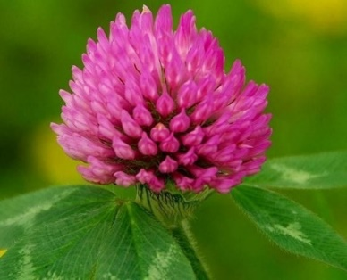
Mapping QTLs for Seed Yield Traits in Red Clover

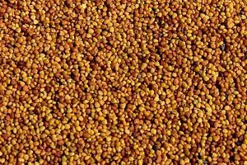
Introduction
Red clover (Trifolium pratense L.) is the most important forage legume species in Norwegian agriculture. It can fix atmospheric nitrogen, has a high feed value, and is therefore a key component of sustainable farming – both conventional and organic. The most common red clover varieties are diploid. However, breeders are making autotetraploid varieties, which have higher yield potentials but they suffer from producing less seed then diploids. The aim of this master project is to map QTLs (Quantitative Trait Loci) for seed yield traits and investigate association with genes expressed during flowering, which have been identified in a recent PhD thesis (Amdahl 2016).

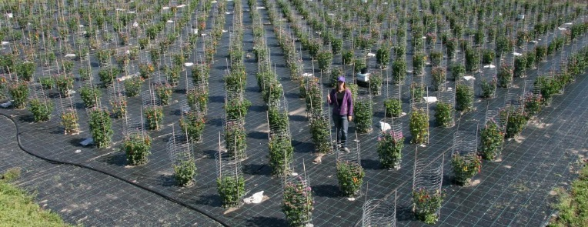
The master project
A mapping population of 200 genotypes were made by crossing a genotype from the variety ‘Tripo’ (a low seed yielding variety) with a genotype from the variety “Lørk” (a high seed yielding variety). The 200 genotypes were cloned, planted in the field (photo right) in 3 replicates and scored for a number of seed yield traits. Dried leaf samples exist of all genotypes DNA. The project involves the following tasks/training: DNA extraction, ddRAD (double digest restriction associated DNA) sequencing, identification of SNP (single nucleotide polymorphism) markers, bioinformatics, and QTL mapping.
You will be supervised and trained at the CIGENE lab, where all the work will be done. You will also get the opportunity to visit and do summer work at the Graminor breeding station at Bjørke, near Hamar.
After this project, you would expected to be familiar with several bioinformatics methods in handling ddRAD sequencing data, identifying and validating SNPs, and methods of QTL mapping. This will give you a strong basis for further PhD studies or work in plant breeding companies.
Contact any of the following:
Prof. Odd Arne Rognli (odd-arne.rognli@nmbu.no)
Dr. Mallikarjuna Rao Kovi (mallikarjuna.rao.kovi@nmbu.no)
Dr. Muath Alsheikh, Graminor (muath.alsheikh@graminor.no)
Dr. Helga Amdahl, Graminor (helga.amdahl@graminor.no)

