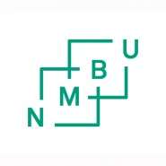
APPLICATION FOR EXTENDED SUBMISSION DEADLINE FOR MASTER/ BACHELOR THESIS
An application for extended deadline must be submitted no later than one (1) month before the original deadline. If the application is due to sickness, a medical certificate must be attached.
Please read Academic regulation at NMBU regarding Master/Bachelor thesis.
Student(s):
Student(s) name
Student number
Study program
Year of admission

Reason for extended submission deadline:
Required new submission deadline (max 3-three-months):

A renewed contract between student(s), supervisor and the faculty must be attached. The contract must be approved by the Faculty.
Signatures :
 | Date: | Signature:
Student(s)
The application must be approved by the Dean at the faculty and the main supervisor:
Dean
Main supervisor

The student(s) and the supervisor(s) must be notified in writing about the outcome of the application for extended submission.
The approved notification must be filed in the student’s file in P360

