NMBU-BIL invite to Bike for Work 2016, 19 April - 17 June
Join and contribute to a healthy workplace! Cycling to work is wonderful and free and easy. Would you like to be in the draw for prizes you must register. It's free for NMBU-BIL members. The first 75 non-members are also free.

Registration is a unique link of the sykletiljobben.no website of; hit this link: http://www.sykletiljobben.no/signup/start/CreateAccountForCompany?companyId=1100180978 . We are registered as
"NMBU-BIL." Create a team of 2-5 persons if you want to join the national competition.

Participation is free for all NMBU-BIL members!
In the campaign you can register:
• The activity to and from work (this applies to awards)
• Other recreational activities such as spinning, walk, aerobics, gardening etc.

The registration takes place either on the website or via the apps Endomondo or Strava. You can create different teams; for example, Institutions or research groups. The kind of "teams" can have a maximum of 5 participants to participate in the national competition prize. Each team has a team leader. See more information on www.sykletiljobben.no.
As a kick-off to this year's Bike for Work, NMBU-BIL offers free "service" of your bike. (It includes lubrication and position of the chain / gear.)
The kick-off will be at the Ås station, Tuesday 19 April, and at Nofima Monday 2 May. Both days from 3:00 p.m. to 5:00 p.m..
One can win great prizes. Under the auspices of NMBU-BIL is the raffle of a wine bottle and some snacks. Also Cycle to Work nationally have prizes. See web page!
In the end of the campaign, there will be prize draw and a shared bicycle trip on Wednesday, June 22nd, starting at 3:15 p.m.
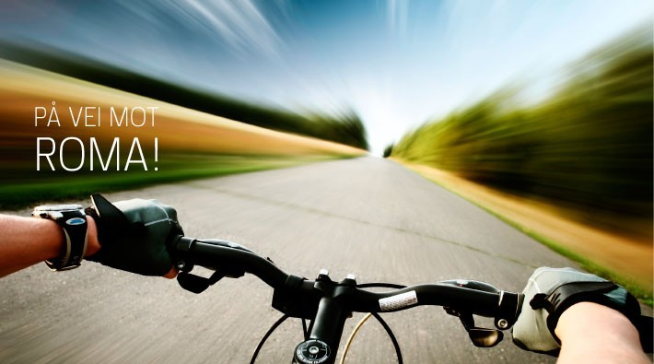
7, good reasons to ride
• For better health
• You save the environment
• You will be happy
• You stay refreshed
• You get more profits and increased work capacity
• You sleep better
• You can whiz past the queue of cars (there are after all queuing at Dairy Crossing)
Prize Conditions
• NMBU-BIL prize: At least 18 days of registration of "activity to / from work." A person can only win one prize.
• Cycle to Work awards: See the web page!

