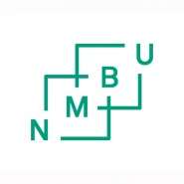
RE- MARKING
(due to complaint)
Please read NMBU’s guidelines for examiners and marking Academic Regulations for NMBU.

Course and Examinee
Course name:
Course code:
Examinee number:
Year: |  | Semester:

Marking:
Final mark (letter mark or pass/fail:

Signature:
 | Date: | Signature:
Examiner (internal)
Examiner (external)

