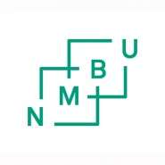
ASSESSMENT PROTOCOL FOR
SPECIAL SYLLABUS

STUDENT
Student name
Student no.
Date of birth
Study programme

INDEPENDENT STUDY
Title in Norwegian
Title in English
Faculty
Year and semester
Level | Bachelor | Master | PhD
 | ☐ | ☐ | ☐
Assessment | A to F | A to F | Pass/Fail
No. of study point

ASSESSMENT
Pass/Fail or
Letter grade A to F

Signatur
 | Date: | Signature:
Internal examiner
External examiner

