**Documentations of FFR1 performances**

**Lars Bakken, Lars Molstad and Jan Reent Köster**

**NMBU 2015**

This is a summary of some essential traits of the Field Flux Robot version 1 (FFR1) for measuring site specific emissions of N2O from the soil surface within field experiments.

**Contents:**

**1. Chamber design and operation**

**2. Leak test of the chambers**

**3. Implications of leakage for estimated emissions**

**4. Detection limits for emission**

**5. Precision of driving, positioning of the robot and chambers**

**Chamber design and operation.**

The chambers of the field robot do not cut into the soil, but close contact with the soil surface is ensured by a ring of ribbed foam rubber which is compressed when landing the chamber on the soil surface. The foam rubber is covered with a flexible gas tight membrane on the inside, to ensure a well-defined soil area which contributes to the measured flux (gas from the soil surface outside the membrane will diffuse out through the foam rubber).

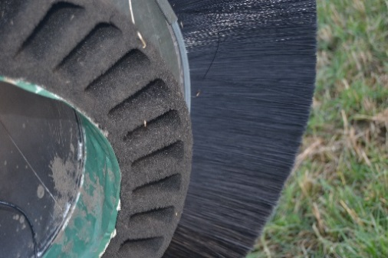

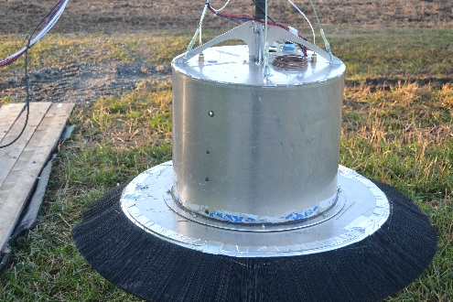

b

a

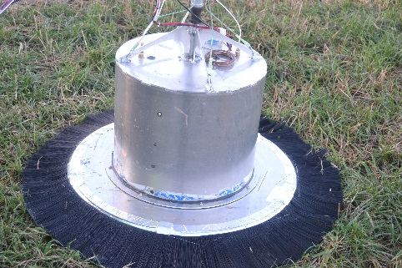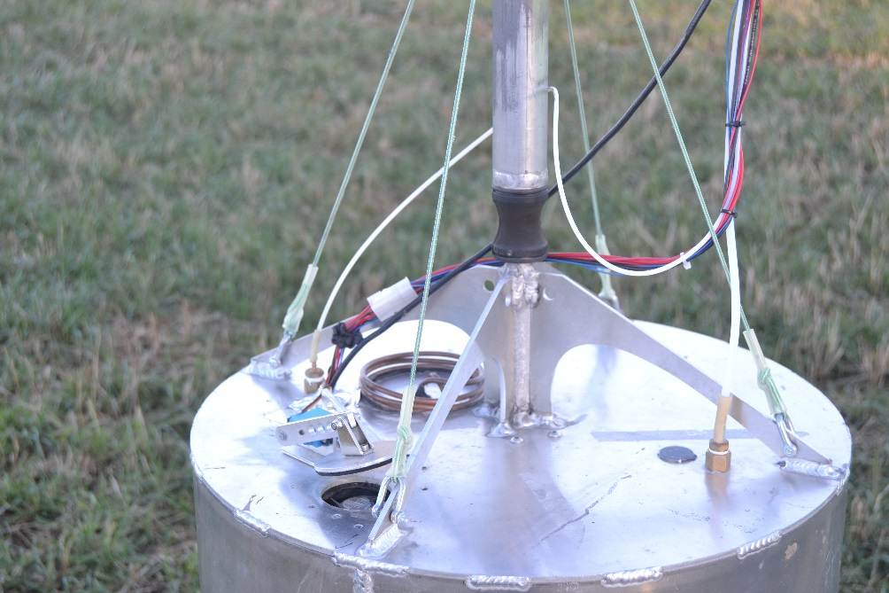

c

d

*Fig. 1: Chamber design. Panel a shows the chamber before deployment, with the ring of nylon brush hairs tilting slightly down. Panel b shows the flexible rubber foam ring with a gas tight coating on the inside, securing a well-defined area which “delivers” N2O and CO2 from the soil surface to the chamber during measurements. Panel c shows the chamber when pressed onto the soil surface. During deployment of the chamber, a lid on top of the chamber (panel d) is kept open to avoid overpressure in the chamber during deployment (as the flexible foam ring is compressed).*

**2. Leak testing of the chambers**

On very rough soil surfaces, the foam rubber may be unable to fit into the deepest crevices, thus providing open channels to the outside. This may cause some bulk transport of air in and out of the chamber, thus leading to errors in the estimated flux (too low estimates). The problem is obviously aggravated by wind. To minimize this problem, the chambers are equipped with long haired brushes as wind shields (Fig. 1).

To quantify the potential problem with such leaks, we conducted a series of experiments where we measured leaks directly under a variety of conditions. The approach was to launch the chamber onto a steel plate, inject a dose of N2O, and monitor the concentration for 3 minutes (the normal deployment time in field operations). To mimic channels between the soil surface and the ring of rubber foam, we placed such channels on the steel frame. The channels consisted 10 cm long PVC tubes with inner diameter 20 mm, which were mounted on the surface with modelling clay to ensure no leaks on the sides (only through the tube).

A series of experiments with different numbers of such channels were run; both in still air, with a fan directed towards the brush (wind speed ~ m s-1) and outdoor under different wind conditions (wind measured by the anemometer at the top of the robot)

An example of the measured N2O after a single injection is shown in Fig. 2. After injection (through the top of the chamber near the gas inlet to the analyzer), it peaked sharply, and took about 40 seconds for the N2O to be evenly distributed in the chamber, thereafter declining at a steady rate, reflecting the leak rate.

To obtain a direct estimate of the leak rate, we assumed that the loss of N2O from the chamber is proportional to the concentration difference between the inside and the outside:

d∆[N2O]/dt = -∆[N2O](t)*L (Eq. 1)

where ∆[N2O](t) is the concentration difference between inside and outside the chamber at time t, L is a measure of the leakage (unit sec-1), either through mass flow through channels or by molecular diffusion (both will be proportional to the concentration difference between the inside and the outside of the chamber).

The integrated function is

∆[N2O](t) = ∆[N2O](t)*e-L*t (Eq. 2)

Hence L can be estimated by linear regression of ln(∆[N2O]) against time.

The unit for L is min-1, and to obtain a measure of leak as mass flow (assuming that all leak is due to mass flow), we multiply L with the volume of the chamber, with is 100 L.

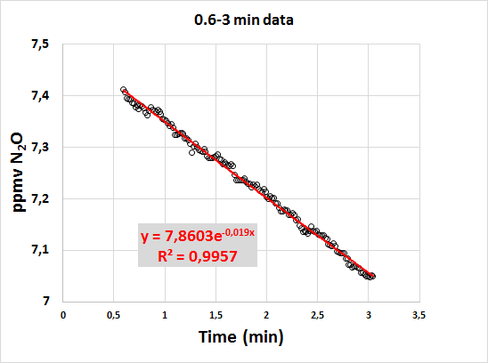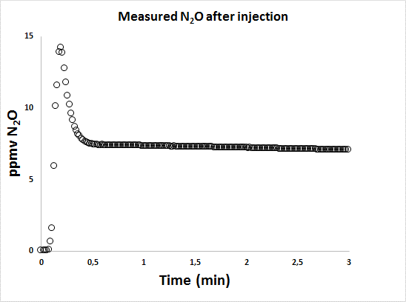

*Fig. 2. N2O after injection. The figure shows the ∆[N2O] = measured N2O concentration minus ambient concentration (0.36 ppmv) after injection of N2O, plotted against time (min). Lower panels shows the data for the 0. -3 min period together with the exponential regression function (equation 2).*

All experiments were run and analysed the same way as shown in Fig. 2, and analyzed by regression of ln(∆[N2O]) against time for the time lapse 50-180 s after injection. Experiments with 0-5 tubes, with and without wind.

The results for the indoor experiments are shown in Table 1

*Table 1. Estimated leak coefficients (L, equation 2) for experiments indoors, with and without fan generated wind speed of X ms-1 directly onto the brush.*

|  |  |  |  |
| --- | --- | --- | --- |
| wind (m s-1) | Number of channels | Average L (min-1)  (stdev) | Number of runs |
| 0 | 0 | 0.0027 (0.00035) | 4 |
| 0 | 2 | 0.024 (0.0031) | 3 |
| 0 | 4 | 0.045 (0.0009) | 3 |
| 3 | 0 | 0.0065 (0.00006) | 3 |
| 3 | 4 | 0.047 (0.002) | 3 |

**3. Implications of leakage for estimated emissions**

The highest leak rate was observed with 4 open channels and strong wind: 0.047 min-1 and is equivalent to 4.7 l min-1 (bulk flow). The error caused by such leaks would be serious with the long closure times used for traditional soil cover methods. However, with only 3 minutes closure time, as used by the field flux robot, the error is in fact quite marginal. This is illustrated in Fig. 3, showing the simulated concentration trajectories for a chamber with the highest leak rate observed.



*Fig. 3. Simulated N2O concentrations in a leaky chamber and the estimated flux. The panels shows the simulated concentrations (ppmv) in a leaky chamber (the highest leak coefficient observed; L= 0.047 min-1, Table 1), the expected concentrations (if no leakage), and the estimated flux (second by second), based on the simulated concentrations. The simulation is for an emission of 11.4 g N2O-N m-2 h-1. Panel A shows the results for 3 minutes, as used by the field robot. Panel B shows the result for 20 min closure time.*

The error caused by leakage increases with time, and would be serious with long closure times as used for traditional soil cover methods which normally use ≥20 min closure times. However, for 3 minutes, the effect of the highest leak coefficient observed (0.047 min-1) is quite modest: assuming that the flux is estimated by linear regression of the realized concentrations against time, we find that the estimate is only 6.5% lower than the true flux (this % error is unaffected by the absolute flux).

**4. Detection limit for emissions**

The lowest emission that can possibly be detected by a 3 min closure time was assessed from the standard deviations of the 1 Hz measurements from a chamber on a steel plate without any N2O injection, which was 0.6 ppb. We can use this to assess the minimum concentration increase over a 180 s period to be detected as statistically significant (by linear regression), which is around 0.2 ppb. An increase of 0.2 ppb over a period of 180 s is equivalent to a flux of 2.3 µg N2O-N m-2 h-1.

**5. Precision of driving, positioning of the robot and buckets at the waypoints**

The precision of the movement of the robot decreases with increasing velocity, and a speed of about 25 m min-1 allowed the robot to keep on the 50 cm wide boardwalks through the plot experiments. To increase the precision in finding the preprogrammed waypoints, the velocity is gradually lowered throughout the last 2 m prior to reaching each measuring waypoint.

To assess the precision of the positioning of the chambers, we have compared the robots’ actual position and orientation (as logged with the GPS), with the programmed positions and directions through our field plot experiments. The results are shown in Fig. 4. The absolute distance from target for the robot was 2 cm ± 1.25 cm (standard deviation). For the bucket positioning, the average off target distance was 3.4 cm ± 1.5 cm. The reason for the somewhat higher deviation for the bucket positioning is due to variation in the orientation. NB: the logged position is that registered by the GPS. Thus, this exercise is a test of the motion; the real precision depends on the precision of the GPS itself.

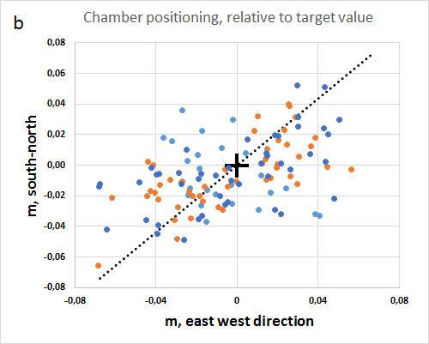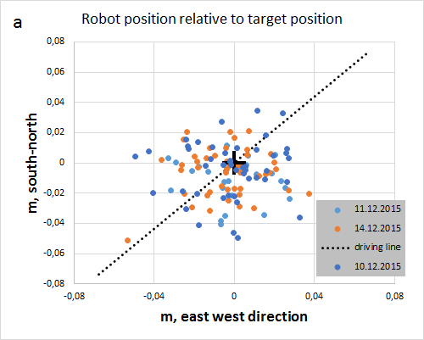

*Fig. 4. Precision of positioning the robot (panel a) and buckets (panel b). The positioning along one of the tracks on three different days of measurements, plotted relative to the target value for each case. The orientation of the boardwalk is indicated by the dashed line.*